**LAB MANUAL**

**OF**

**DAA LAB**



SUBMITTED TO

**Mandeep Kaur Ma’am**

**NAME – MOHIT RANJAN**

**ROLL -230103095**

**GRP – G1**

**Department of Computer Science and Engineering**

**DR. B.R. AMBEDKAR NATIONAL INSTITUTE OF TECHNOLOGY JALANDHAR, PUNJAB-144011**

**LAB 1**

**Bubble Sort:**

*#include* <iostream>

using namespace std;

void printCount(int *count*) {

    cout << "Number of iterations: " << count << endl;

}

void bubbleSort(int *arr*[], int *n*) {

    int iterationCount = 0;

    bool swapped;

*for* (int i = 0; i < n - 1; i++) {

        swapped = false;

*for* (int j = 0; j < n - i - 1; j++) {

            iterationCount++;

*if* (arr[j] > arr[j + 1]) {

                int temp = arr[j];

                arr[j] = arr[j + 1];

                arr[j + 1] = temp;

                swapped = true;

            }

        }

*if* (!swapped) {

            cout << "Best case" << endl;

*break*;

        }

    }

    printCount(iterationCount);

}

void printArray(int *arr*[], int *size*) {

*for* (int i = 0; i < size; i++)

        cout << arr[i] << " ";

    cout << endl;

}

int main() {

    int n;

    cout << "Enter the size of the array: ";

    cin >> n;

    int arr[n];

    cout << "Enter " << n << " elements of the array: ";

*for* (int i = 0; i < n; i++) {

        cin >> arr[i];

    }

    cout << "Original Array: ";

    printArray(arr, n);

    bubbleSort(arr, n);

    cout << "Sorted Array: ";

    printArray(arr, n);

*return* 0;

}

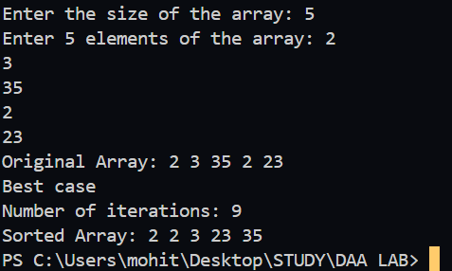

**Insertion Sort**

*#include* <iostream>

*#include* <vector>

using namespace std;

void insertionSort(vector<int> & *arr* , int& *iterations*) {

  int n = arr.size();

*for* (int i = 1; i < n; ++i) {

    int key = arr[i];

    int j = i - 1;

*while* (j >= 0 && arr[j] > key) {

      arr[j + 1] = arr[j];

      --j;

      ++iterations;

    }

    arr[j + 1] = key;

  }

}

int main(){

  int n;

  cout << "Enter the number of elements: ";

  cin >> n;

  vector<int> arr(n);

  cout << "Enter the elements: ";

*for* (int i = 0; i < n; ++i) {

    cin >> arr[i];

  }

  int iterations = 0;

  insertionSort(arr, iterations);

  cout << "Sorted array: ";

*for* (int i = 0; i < arr.size(); ++i) {

    cout << arr[i] << " ";

  }

  cout << endl;

  cout << "Number of iterations: " << iterations << endl;

*return* 0;

}

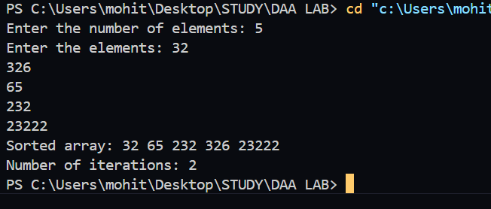

**LEETCODE PROBLEMS**

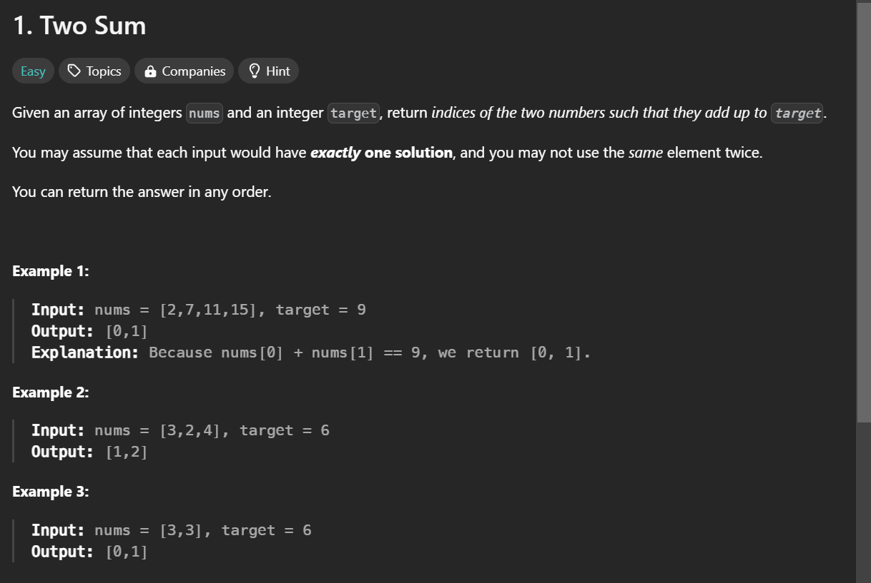

class Solution {

public:

    vector<int> twoSum(vector<int>& nums, int target) {

        int n = nums.size();

        for(int i=0;i<n;i++){

            for(int j=i+1;j<n;j++){

                if(nums[i]+nums[j]==target){

                    return{i,j};

                }

            }

        }

        return {-1,-1};

    }

};

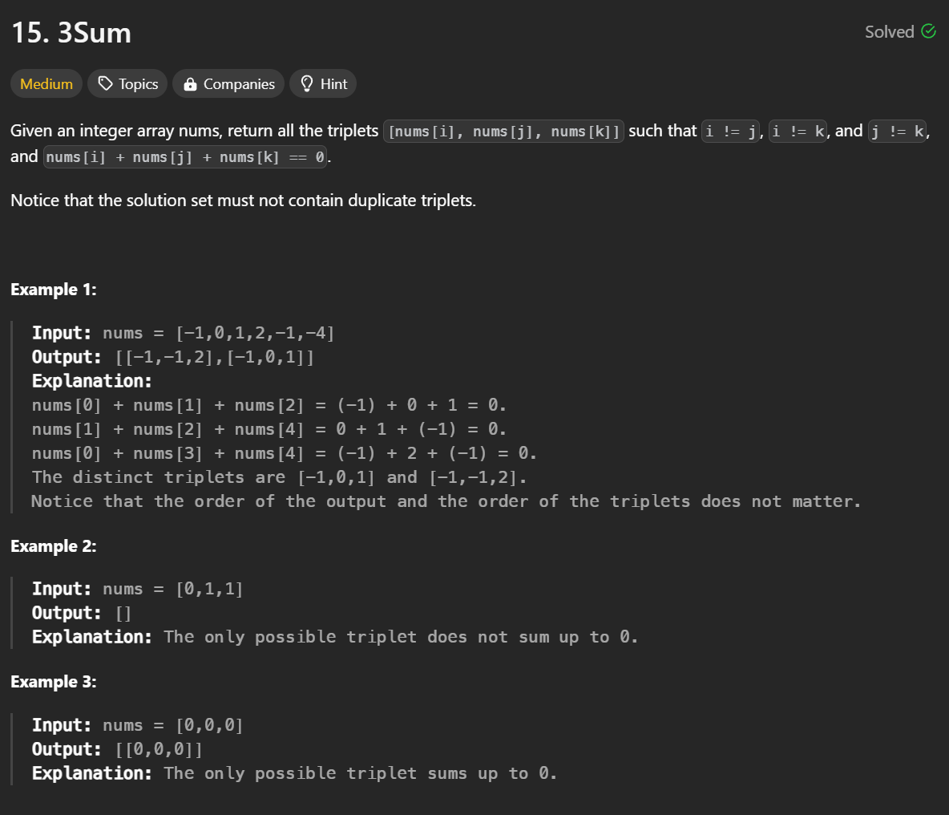

**class Solution {**

**public:**

**vector<vector<int>> threeSum(vector<int> &nums) {**

**sort(begin(nums), end(nums));**

**vector<vector<int>> result;**

**for (int i = size(nums) - 1; i >= 2; --i) {**

**if (i + 1 < size(nums) && nums[i] == nums[i + 1]) {**

**continue;**

**}**

**const auto& target = -nums[i];**

**int left = 0, right = i - 1;**

**while (left < right) {**

**if (nums[left] + nums[right] < target) {**

**++left;**

**} else if (nums[left] + nums[right] > target) {**

**--right;**

**} else {**

**result.push_back({nums[left], nums[right], nums[i]});**

**++left; --right;**

**while (left < right && nums[left] == nums[left - 1]) {**

**++left;**

**}**

**while (left < right && nums[right] == nums[right + 1]) {**

**--right;**

**}**

**}**

**}**

**}**

**return result;**

**}**

**};**